VAN LANG UNIVERSITY
FACULTY: ARCHITECTURE

ANSWER KEYS FOR THE END-OF-COURSE EXAMINATION (1ST TIME)
Semester 2 , Year 2022 - 2023

Course code: 222_7AR0220_01
Course name: Architectural physics 1
Group code: K26DB-A01 K26DB-AR
Duration (minute/day): 60 minutes
Format: Essay

Format nội dung đáp án đề thi:
- Font: Times New Roman
- Size: 13

A 1 (6 điểm):
How to determine the size of a sun visor using the histogram method. (4 points)
Horizontal sun visor
To determine the size of the shading structure, It is important to know the direction of the door, the required shading time.
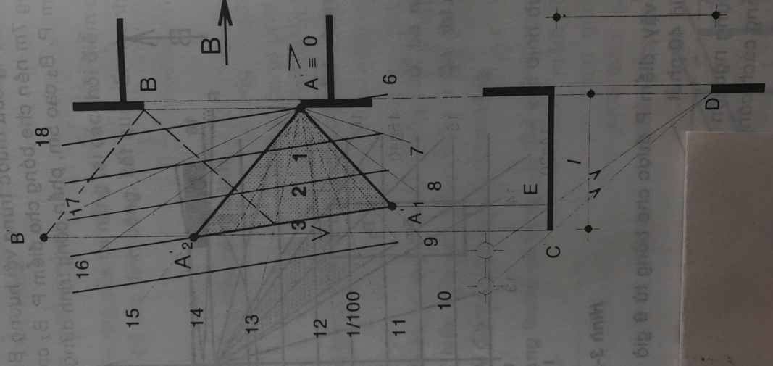
For example, we must determine the size of the horizontal sun visor to ensure sun protection from 9h to 15h on Spring – Autumn Equinox, and ensure works are situated at latitude $φ$ = 10⁰.
H=3m
1. Draw the floor plan and section in proportion to the shadow ruler.
2. Place the spring – autumn shadow ruler on the drawing, with point O of the ruler coinciding with the calculation point – point A. The direction of the ruler points to the north of the project.
3. Identify the sun rays of 9am and 3pm. The door is 3m high. The shadow of A is the intersection of the 3m line with the 9am and 3pm sun rays.
4. Project 2 shadow points A'1 and A'2 down to the sun visor position on the section to have C and E.
5. CD and ED are 2 sunrays at 9am and 3pm.
To ensure sun protection for the door surface, just move line AA'1A'2 to point B to have the required sun visor AA'1B'B.
6. The designer decides the shape of the sun visor by himself.
A 2 (6 điểm)
How do the window placement and the angle of open windows affect the air circulation going through the house? Draw the illustrations and explain.
The wind moves like an endless long invisible rope. It will slip through any holes it encounters along the way. This means that if a room or a house has only one door for the wind to enter without an escape route, the wind will definitely not enter. At the same time, the location of the windows also plays an important role, affecting the circulation of wind in the house.
The direction of the trans-room current depends on the pressure distributed on the 2 edges of the wind-catching door. If the pressure is evenly distributed, the current is constant and its direction remains intact.
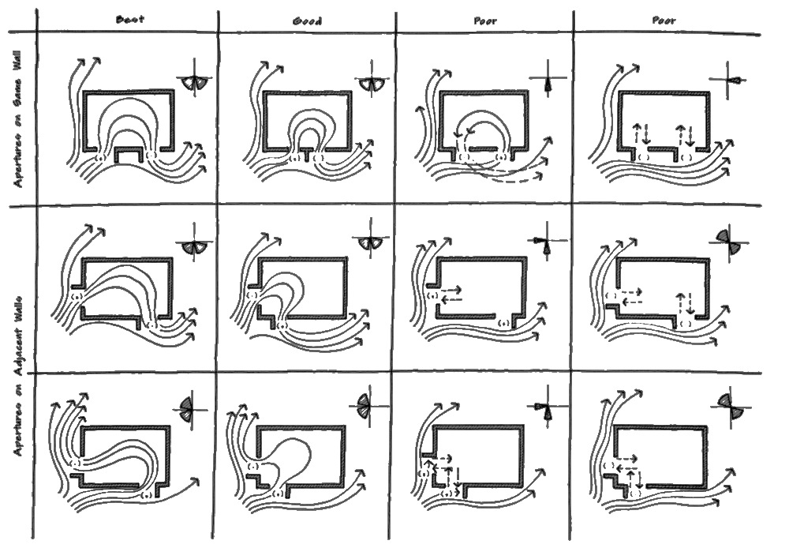

Ngày biên soạn: 8/03/2023
Giảng viên biên soạn đáp án đề thi: Th.S KTS Nguyễn Thị Việt Hà

Ngày kiểm duyệt:
Trưởng (Phó) Khoa/Bộ môn kiểm duyệt đề thi: Th.S KTS Nguyễn Bảo Tuấn

Sau khi kiểm duyệt đề thi, Trưởng (Phó) Khoa/Bộ môn gửi về Trung tâm Khảo thí qua email: khaothivanlang@gmail.com bao gồm file word và file pdf (được đặt password trên 1 file nén/lần gửi) và nhắn tin password + họ tên GV gửi qua Số điện thoại Thầy Phan Nhất Linh (0918.01.03.09).

