TRƯỜNG ĐẠI HỌC VĂN LANG
KHOA: NGOẠI NGỮ

ĐỀ THI VÀ ĐÁP ÁN ĐỀ THI KẾT THÚC HỌC PHẦN
Học kỳ 3 , năm học 2021 - 2022

Mã học phần: DTA0155
Tên học phần: Tiếng Anh 5
Mã nhóm lớp học phần: 213_DTA0155
Thời gian làm bài (phút/ngày): 60 phút
Hình thức thi: Trắc nghiệm kết hợp tự luận
Cách thức nộp bài phần tự luận (Giảng viên ghi rõ yêu cầu):
Gợi ý:
- SV gõ trực tiếp trên khung trả lời của hệ thống thi;

PHẦN TRẮC NGHIỆM (6 điểm)

Part I. Questions 1-10
For each question, choose the correct answer (A, B, C, or D)
I spoke to __________hotel manager about the problem with our room.
A. the
B. a
C. any
D. some
ANSWER: A

I __________ early tomorrow morning.
A. am going to wake up
B. woke up
C. wake up
D. was waking up
ANSWER: A

I __________ John at the party yesterday.
A. saw
B. see
C. have seen
D. was seeing
ANSWER: A

__________ the rain, they moved the concert inside.
A. Because of
B. Despite
C. However
D. Even though
ANSWER: A

He will take the dog out for a walk as soon as he __________ dinner.
A. finishes
B. finish
C. will finish
D. shall have finished
ANSWER: A

She __________ the living room when she heard a strange noise in the kitchen.
A. was cleaning
B. has cleaned
C. has been
D. cleaning
ANSWER: A

She was playing games while he __________ a football match.
A. was watching
B. watched
C. watches
D. watching
ANSWER: A

Look! That man __________to open the door of your car.
A. is trying
B. try
C. tried
D. has tried
ANSWER: A

__________ in a foreign country can be very difficult.
A. Living
B. Live
C. Lived
D. To living
ANSWER: A

She is __________singer I’ve ever met.
A. the worst
B. worse
C. bad
D. badly
ANSWER: A

Part II. Questions 11-15
For each question, choose the correct answer (A, B, or C)

11.
A. Tony needs to collect the book he asked for, by Friday.
B. The bookshop will get Tony’s book on Friday
C. The book is being delivered to Tony’s house on Friday
ANSWER: A

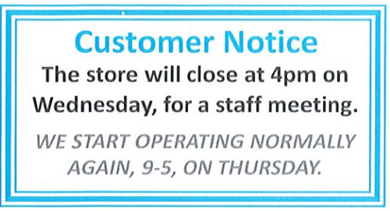

12.
A. On Wednesday, the store will close an hour earlier than usual.
B. The store will open later than normal on Wednesday.
C. The store usually closes at 5pm, except Wednesdays
ANSWER: A

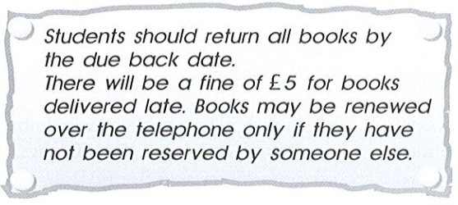
13. Students are informed that
A. it is essential that all books be taken back on time.
B. if they wish to renew a book they can only do so by telephone
C. if anyone wants to borrow a book, they must reserve it in advance.
ANSWER: A

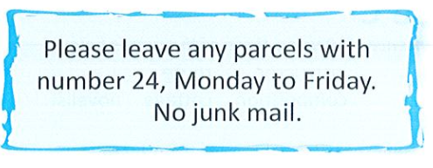

14.
A. You are not allowed to post any junk mail here.
B. All post should be taken to number 24 on weekdays.
C. No mail is accepted at weekends from apartment 24.
ANSWER: A

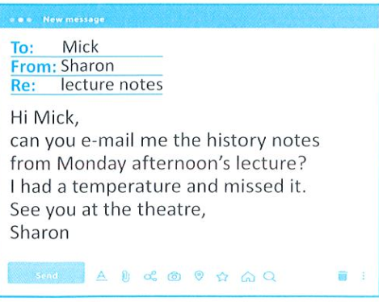

15.
A. Sharon was too ill to attend the history lecture.
B. It was too hot for Sharon to go to the history lecture.
C. Sharon went to the theatre instead of the lecture.
ANSWER: A
Part III. Questions 16-24
For each question, choose the correct answer (A, B, C, or D)

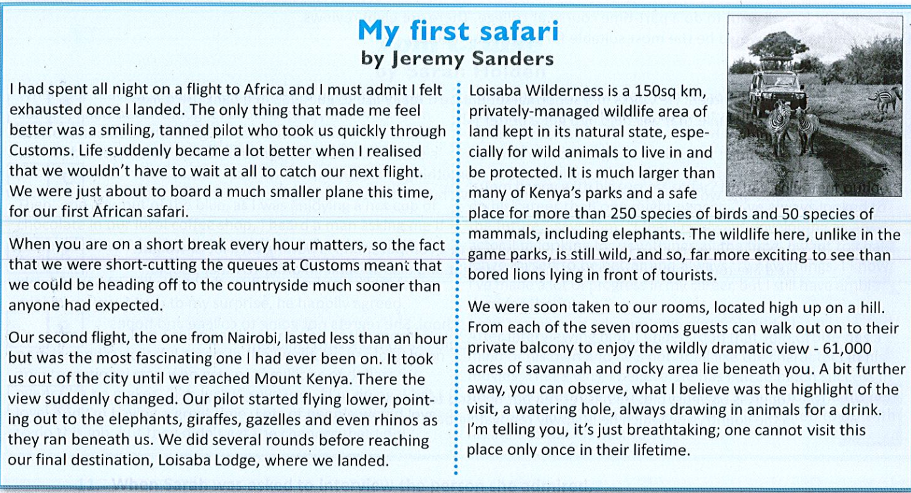

16. When Jeremy arrived in Africa
A. he was too tired after the long flight.
B. he was quite excited about his trip.
C. he felt anxious about what was going to happen next.
D. he needed to get a good sleep as it was the middle of night
ANSWER: A

17. Why was Jeremy so pleased to be met by the pilot?
A. Because he wanted to make the most of his time on holiday.
B. Because he thought the pilot might not meet him
C. Because he expected the pilot to be unfriendly.
D. Because he did not know where to go.
ANSWER: A

18. What does Jeremy say about the flight from Nairobi?
A. It offered many impressive views.
B. It was far too long.
C. The pilot flew in a dangerous way
D. They were followed by a smaller plane.
ANSWER: A

19. What does Jeremy suggest about Loisaba?
- It is still a safe and natural environment for animals.
- Tourists are no longer allowed there.
- Many of the animals are being hunted.
- The wild animals often attack people.
ANSWER: A

20. Which of the following might Jeremy write about his experience?
A. “It was thrilling to get a taste of natural Africa. It has been without a doubt an unforgettable experience”
B. “Unfortunately tourists are once again taking over beautiful Africa. They are ruining the land – scape and threatening the animals’ survival.”
C. “ I am really concerned about the wild animals in Africa as they are facing great dangers. We should take measures”
D. “ Visiting Africa does not differ much from a day trip to the zoo. The conditions and animal facilities are almost the same”
ANSWER: A

Read an article about Tadao Ando. Then answer questions 21-24.
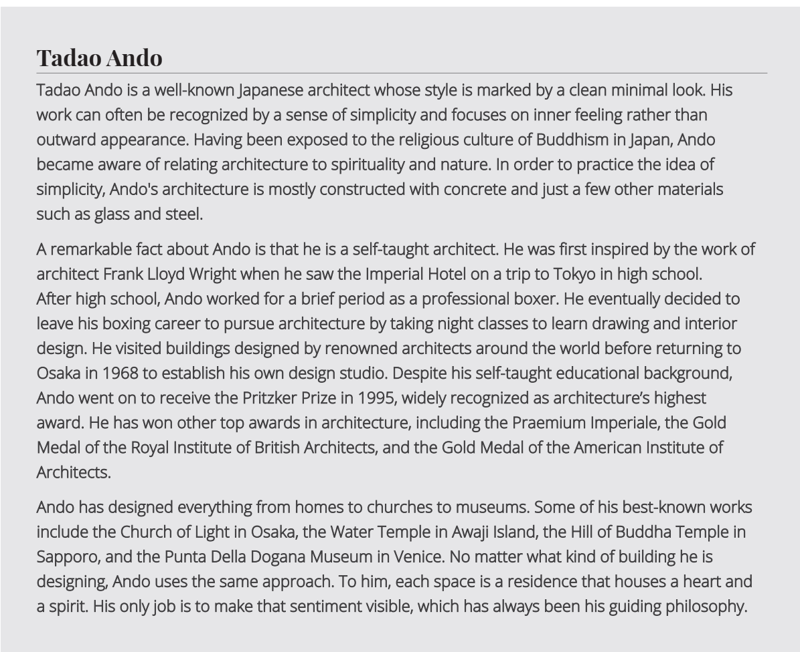

21. What is a distinguishing feature of Ando’s work?
A. Use of concrete
B. Complex design
C. Physical beauty
D. Relation to Japan
ANSWER: A

22. What is significant about the fact that Ando received the Pritzker Prize?
A. Ando has had no formal education in architecture.
B. Ando doesn’t believe there should be prizes in architecture.
C. It is the highest prize in architecture.
D. It is given to only a few architects.
ANSWER: A

23. What is one of Ando’s best – known works?
A. The Church of Light
B. The Imperial Hotel
C. The Praemium Imperiale
D. The Royal Institute of British Architects
ANSWER: A

24. What is the main influence in Ando’s work?
A. His spiritual beliefs
B. Works of famous architects
C. Teachings in interior design
D. His former boxing career
ANSWER: A

Part IV. Questions 25-30
For each question, choose the correct answer (A, B, C, or D)

Working as cabin crew
If you had asked Ann a few years ago what she would be doing in five years’ time, she wouldn’t have believed you if you had suggested she would be a cabin crew member. When she told her friends that she had __________ (25) for such a job, most of them laughed.

However, after successfully __________(26) her four – week cabin crew training __________(27), the only person laughing now is Ann! Like many cabin crew, Ann is expected to work at any time of the day on any day of the year, and sometimes she has to work up to 12 hours a day. So the days can be long and the work tiring, but Ann is enjoying the unique and __________(28) lifestyle that being cabin crew brings.

Ann can enjoy a __________ (29) of up to 17,000 pounds ( or 20,000 pounds when she becomes a senior cabin crew member) and 36 days off per year. If you would like to __________(30) in Ann’s footsteps, and work as cabin crew, it seems you simply have to get ready for a life of adventure. Most people would say it’s worth it!

25.
A. applied
B. hired
C. requested
D. employed
ANSWER: A

26.
A. completing
B. believing
C. starting
D.working
ANSWER: A

27.
A. course
B. education
C. lesson
D. subject
ANSWER: A

28.
A. challenging
B. confused
C. anxious
D. unreliable
ANSWER: A

29.
A. salary
B. fee
C. saving
D. bill
ANSWER: A

30.
A. follow
B. run
C. go
D. be
ANSWER: A

PHẦN TỰ LUẬN (4 điểm)
Câu 1 (4 điểm):

Đáp án Câu 1: The answer may vary.
Ngày biên soạn: 20/06/2022
Giảng viên biên soạn đề thi: Nguyễn Thị Thu Thủy

Ngày kiểm duyệt: 29/6/2022
Phó Bộ môn kiểm duyệt đề thi: Nguyễn Thanh Minh

