TRƯỜNG ĐẠI HỌC VĂN LANG
KHOA: NGOẠI NGỮ

ĐỀ THI VÀ ĐÁP ÁN ĐỀ THI KẾT THÚC HỌC PHẦN
Học kỳ 3 , năm học 2021 - 2022

Mã học phần: DTA0155
Tên học phần: Tiếng Anh 5
Mã nhóm lớp học phần: 213_DTA0155
Thời gian làm bài (phút/ngày): 60 phút
Hình thức thi: Trắc nghiệm kết hợp tự luận
Cách thức nộp bài phần tự luận (Giảng viên ghi rõ yêu cầu):
Gợi ý:
- SV gõ trực tiếp trên khung trả lời của hệ thống thi;

PHẦN TRẮC NGHIỆM (6 điểm)

Part I. Questions 1-10
For each question, choose the correct answer (A, B, C, or D)
They __________ a lot of time together recently.
A. have been spending
B. had spent
C. will spend
D. were spending
ANSWER: A

When I lived in New York, I __________ pick up a bagel and coffee on my way to work every morning.
A. would
B. should
C. must
D. might
ANSWER: A

Yesterday John told me a joke. It is __________one I’ve ever heard
A. the funniest
B. the funnier
C. funniest
D. the more funnier
ANSWER: A

Losing your credit card is _______ than losing your money
A. worse
B. bader
C. more bad
D. worst
ANSWER: A

That was __________sandwich. I’m so full!
A. such a big
B. so big
C. very big
D. such big
ANSWER: A

You can’t wear shoes in the house. Please __________
A. take them off
B. take off them
C. them off take
D. them take off
ANSWER: A

If you __________ more, your vocabulary would be better.
A. had read
B. will read
C. have read
D. are reading
ANSWER: A

Please don’t touch the plates. They are __________
A. extremely hot
B. extreme heat
C. hotter
D. the hottest
ANSWER: A

How _______ since we _______college?
A. have you been - left
B. are you - left
C. were you - left
D. have you been– have left
ANSWER: A

We have _______money left, so we’re going to shop some more.
A. a little
B. few
C. a few
D. little
ANSWER: A

Part II. Questions 11-15
For each question, choose the correct answer (A, B, or C)

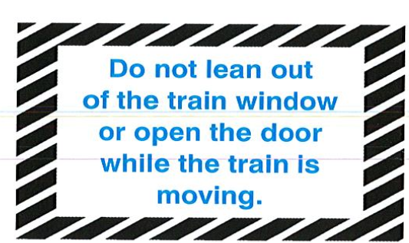

11.
A. Passengers are prohibited from putting their head out of the window when the train has left the station.
B. Passengers are informed that they are not allowed to open train windows.
C. Train windows are to open only when the train has entered a station.
ANSWER: A

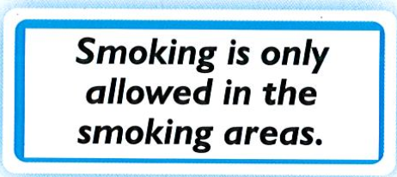

12.
A. There are certain places where you can smoke.
B. You are not allowed to smoke anywhere in the building.
C. You must smoke if you are in one of the building’s smoking areas.
ANSWER: A

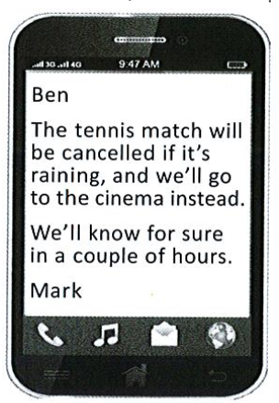
13. Mark is letting Ben know
A. there is a chance they might not play tennis, depending on the weather.
B. they are not going to play tennis because of a change of plans.
C. they will go to the cinema in a few hours, so he must get ready.
ANSWER: A

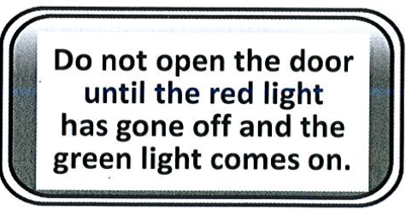

14.
A. Wait for the green light before opening the door.
B. Turn off the red light when you open the door.
C. Do not open the door when the green light is on
ANSWER: A

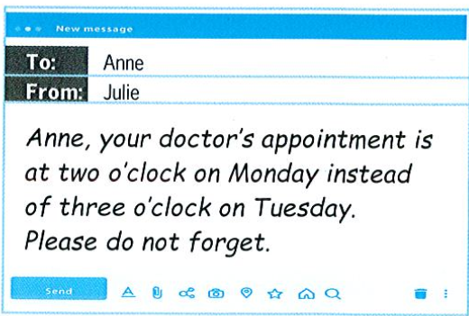

15.
A. Anne’s appointment will no longer be on Tuesday.
B. Anne’s appointment will be a day later.
C. Anne’s appointment will be an hour later.
ANSWER: A
Part III. Questions 16-24
For each question, choose the correct answer (A, B, C, or D)

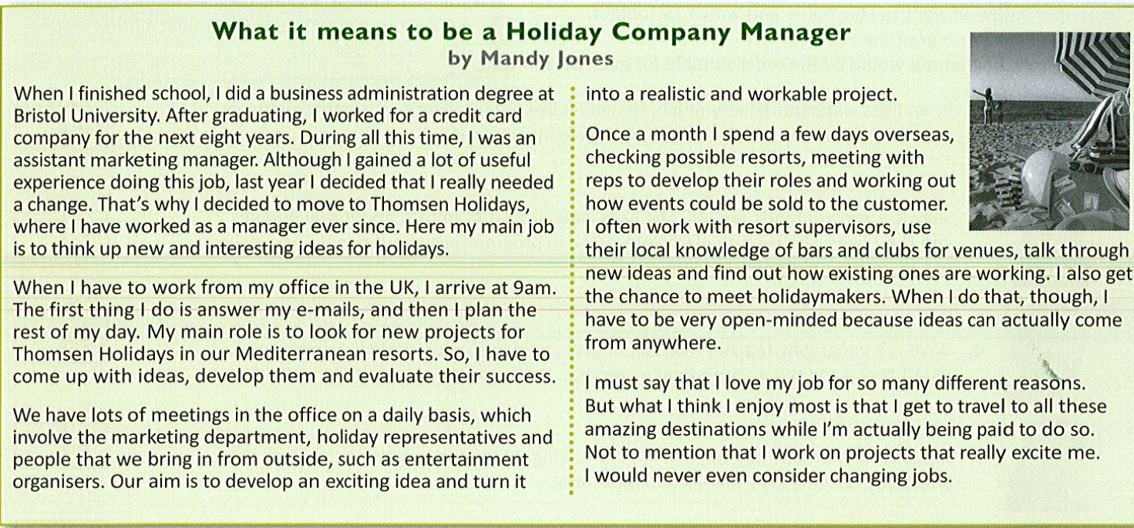

16. What do we learn about the writer in the first paragraph?
A. She learned a lot form her first job.
B. She disliked her first job.
C. She was fired from her first job.
D. Her first job was with Bristol University.
ANSWER: A

17. Mandy has to
A. find out if new ideas could actually work.
B. send e – mails all day.
C. entertain the holiday reps.
D. spend all of her time having meetings in the office.
ANSWER: A

18. What does Mandy say about her job?
A. She never knows where or how a new idea might come to her.
B. It makes her very popular with lots of people.
C. She spends too much time in bars and clubs.
D. She has a few problems with local people at the resorts.
ANSWER: A

19. What Mandy really likes about being a holiday company manager is that.
- she has to do a lot of travelling as part of her work.
- she always has a lot of work to do.
- she decides on which projects she wants to work.
- she is still excited about going to the office every day.
ANSWER: A

20. Which of the following is the best description of Mandy?
A. A working woman who very much enjoys what she does for a living.
B. A travel agent who is trying to get a promotion.
C. A woman who makes a lot of money by going to clubs and bars.
D. A woman who spends a lot of time on holiday and has an easy life
ANSWER: A

Read an article about Tadao Ando. Then answer questions 21-24.
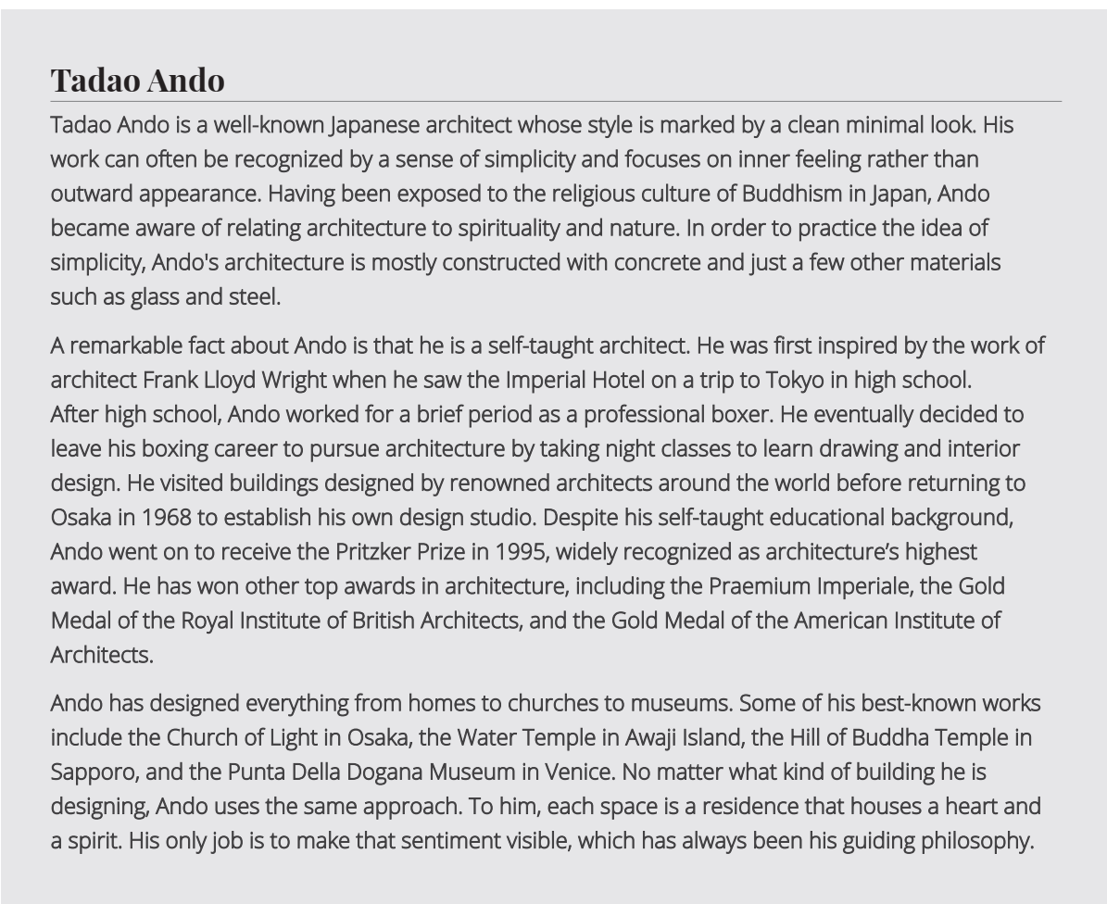

21. What is a distinguishing feature of Ando’s work?
A. Use of concrete
B. Complex design
C. Physical beauty
D. Relation to Japan
ANSWER: A

22. What is significant about the fact that Ando received the Pritzker Prize?
A. Ando has had no formal education in architecture.
B. Ando doesn’t believe there should be prizes in architecture.
C. It is the highest prize in architecture.
D. It is given to only a few architects.
ANSWER: A

23. What is one of Ando’s best – known works?
A. The Church of Light
B. The Imperial Hotel
C. The Praemium Imperiale
D. The Royal Institute of British Architects
ANSWER: A

24. What is the main influence in Ando’s work?
A. His spiritual beliefs
B. Works of famous architects
C. Teachings in interior design
D. His former boxing career
ANSWER: A

Part IV. Questions 25-30
For each question, choose the correct answer (A, B, C, or D)

“ Ask your pharmacist first”
When you have so many __________(25) to do at school, and even some homework back at home, the last thing you want is a(n) __________(26) throat or a headache to drag you down.

“Prevention is better than cure” is what most people say, meaning that it is always best to try not to get sick than to find ways to get better when you do. But what happens when you haven’t __________(27) yourself for the winter? At some point in autumn you’ll start feeling down and that’s when you should remember that a visit to your __________(28) pharmacy can be a real bonus in helping you get well soon.

But it’s not just the medication that assists the cure – only at a pharmacy will you find expert ________ (29) from a highly trained health professional. Your pharmacist will gladly __________(30) what he believes is best for you. So, by working together, you can be sure that your medications are taken safely and effectively to maintain your good health.

25.
A. projects
B. duties
C. jobs
D. works
ANSWER: A

26.
A. sore
B. cut
C. hurt
D. injured
ANSWER: A

27.
A. prepared
B. arranged
C. planned
D. trained
ANSWER: A

28.
A. local
B. native
C. national
D. home
ANSWER: A

29.
A. advice
B. treatment
C. preparation
D. therapy
ANSWER: A

30.
A. recommend
B. command
C. order
D. sign
ANSWER: A

PHẦN TỰ LUẬN (4 điểm)
Câu 1 (4 điểm):
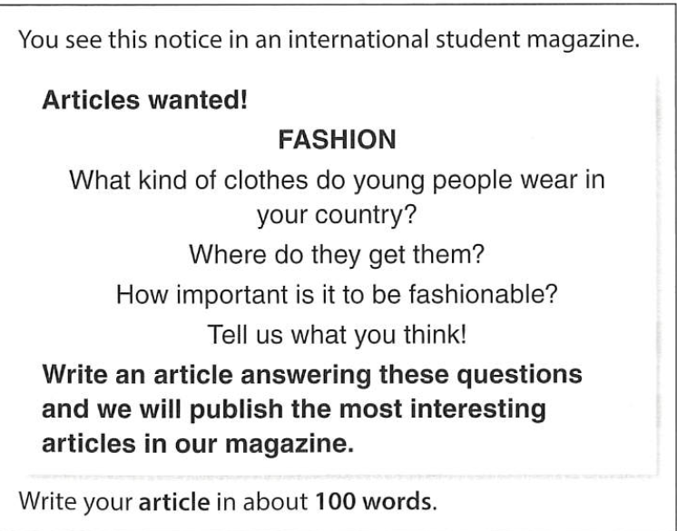

Đáp án Câu 1: The answer may vary.
Ngày biên soạn: 20/06/2022
Giảng viên biên soạn đề thi: Nguyễn Thị Thu Thủy

Ngày kiểm duyệt: 29/6/2022
Phó Bộ môn kiểm duyệt đề thi: Nguyễn Thanh Minh

