TRƯỜNG ĐẠI HỌC VĂN LANG
KHOA: NGOẠI NGỮ

ĐỀ THI VÀ ĐÁP ÁN ĐỀ THI KẾT THÚC HỌC PHẦN
Học kỳ 3 , năm học 2021 - 2022

Mã học phần: 71CLAN30033
Tên học phần: Tiếng Anh 2
Mã nhóm lớp học phần: 213_71CLAN30033
Thời gian làm bài (phút/ngày): 60 phút
Hình thức thi: Trắc nghiệm kết hợp tự luận
Cách thức nộp bài phần tự luận (Giảng viên ghi rõ yêu cầu):
Gợi ý:
- SV gõ trực tiếp trên khung trả lời của hệ thống thi;

PHẦN TRẮC NGHIỆM (6 điểm)

Part I. Questions 1-19
For each question, choose the correct answer (A, B, C, or D)

Learning to speak a language is often much __________than learning to write it.
A. easier
B. easily
C. more easy
D. easiest
ANSWER: A

The less he slept, __________he became
A. the more irritable
B. the irritable
C. the better irritable
D. the most irritable
ANSWER: A

Yesterday John told me a joke. It is __________one I’ve ever heard
A. the funniest
B. the funnier
C. funniest
D. the more funnier
ANSWER: A

Losing your credit card is _______ than losing your money
A. worse
B. bader
C. more bad
D. worst
ANSWER: A

These trousers are too small for me. I need _______ ones
A. larger
B. large
C. more large
D. largest
ANSWER: A

In all the world, there _______ only 14 mountains that reach above 8,000 meters
A. are
B. be
C. is
D. am
ANSWER: A

His health has improved since he _______ from the hills.
A. returned
B. return
C. would return
D. returning
ANSWER: A

Christopher Columbus _______ American more than 500 years ago.
A. discovered
B. has discovered
C. had discovered
D. had been discovering
ANSWER: A

Which word is different from others?
A. pink
B. apple
C. watermelon
D. mango
ANSWER: A

Which word is different from others?
A. sneakers
B. frying pan
C. pot
D. bowl
ANSWER: A

How _______ since we _______college?
A. have you been - left
B. are you - left
C. were you - left
D. have you been – have left
ANSWER: A

When we attend the meeting with Mr. Minh tomorrow, I _______ him of that.
A. will remind
B. remind
C. have reminded
D. reminded
ANSWER: A

In 1970, the Canadian scientist George Kelly _______ that warm water _______more quickly than cold water
A. proved - freezes
B. prove - freeze
C. proves - freezed
D. proved - freezed
ANSWER: A

My friend, David, _______to school late which annoys our teacher so much.
A. is always going
B. always goes
C. has always gone
D. will always go
ANSWER: A

While we were watching TV, our dad _______ to the radio
A. was listening
B. were listening
C. had been listening
D. is listening
ANSWER: A

I’m in a rush now because the train _______at 4 o’clock. I have only 10 minutes left!
A. departs
B. depart
C. will depart
D. is going to depart
ANSWER: A

He _______his homework in his bedroom when the burglar came into the house
A. was doing
B. is doing
C. has been doing
D. did
ANSWER: A

How _______cakes does she want?
A. many
B. some
C. any
D. much
ANSWER: A

Peter doesn’t want _______eggs, but he wants some soup.
A. any
B. some
C. many
D. much
ANSWER: A

Part II. For each question, choose the correct answer (A, B, or C) to fill in the blank.

Dakota Fanning
Dakota Fanning was born on February 23rd 1994, in Georgia, USA. She began acting classes at a very _______(20) age and starred in her first TV advert when she was just five years old.
After that, she had a long and successful _______(21) as a child actor in both TV shows and films. In 2001, she _______(22) an important prize for her part in the film I am Sam. Over the next ten years, she acted with many big Hollywood stars, including Reese Witherspoon, Tom Cruise and Kurt Russell.
Dakota Fanning is different from many child actors because her success continued as she _______(23) up and became an adult. In 2018, she _______(24) to TV for the first time in ten years, starring in a popular police set in the nineteenth century, _______(25) The Alienist.

20.
A. early
B. small
C. little
ANSWER: A

21.
A. career
B. job
C. occupation
ANSWER: A

22.
A. won
B. did
C. earned
ANSWER: A

23.
A. grew
B. got
C. went
ANSWER: A

24.
A. returned
B. changed
C. arrived
ANSWER: A

25.
A. called
B. told
C. said
ANSWER: A

Part III. Read the following passage and answer the questions

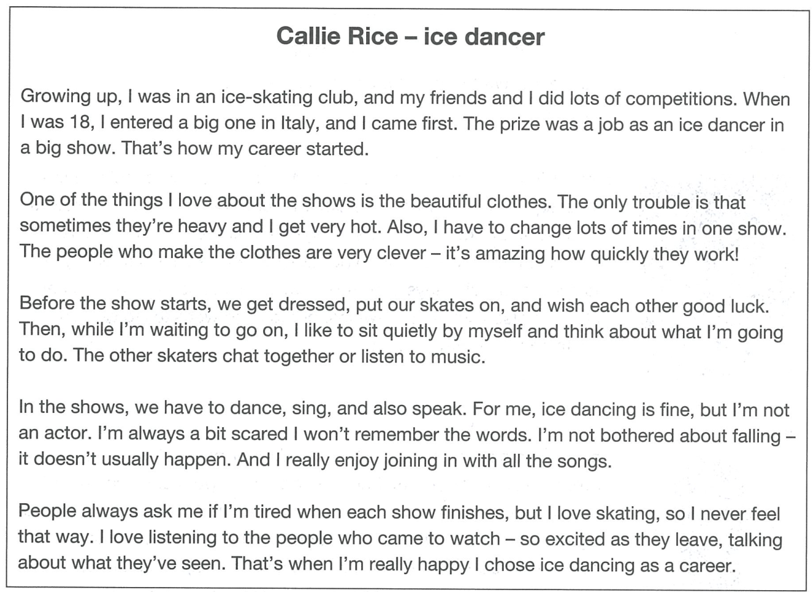
26. How did Callie’s career as an ice dancer begin?
- She won a competition.
- She saw an advert for a job.
- A friend invited her to join an ice show.
ANSWER: A

27. What does Callie say about the clothes she wears?
- It’s hard to skate in them.
- Some are prettier than others.
- Making them takes a long time.
ANSWER: A

28. What does Callie do just before each show?
- She takes a moment to be alone.
- She talks to the other skaters
- She checks her skates are okay
ANSWER: A

29. What does Callie worry about?
- forgetting what she has to say
- having an accident on the ice
- dancing and singing at the same time
ANSWER: A

30. How does Callie usually feel after a show?
- pleased about making people happy
- ready for a rest
- glad that she’s finished
ANSWER: A

PHẦN TỰ LUẬN (4 điểm)
Câu 1 (4 điểm): You want to go to an after – school art club with your English friend Peter on Monday.
Write an email to Peter
In your email:
- say why you want him to come with you
- explain what you will do there
- suggest how to get back home after the club
Write 50 words or more.
Đáp án Câu 1: The answer may vary.
Ngày biên soạn: 20/06/2022
Giảng viên biên soạn đề thi: Nguyễn Thị Thu Thủy

Ngày kiểm duyệt:29/6/2022
Phó Bộ môn kiểm duyệt đề thi: Nguyễn Thanh Minh

