TRƯỜNG ĐẠI HỌC VĂN LANG
KHOA: QUẢN TRỊ KINH DOANH

ĐỀ THI VÀ ĐÁP ÁN ĐỀ THI KẾT THÚC HỌC PHẦN
Học kỳ 3, năm học 2021 - 2022

Mã học phần: 2137QT0230
Tên học phần: Leadership Skills
Mã nhóm lớp học phần: 213_7QT0230_01
Thời gian làm bài (phút/ngày): 13:30 – 14:45 / 08.08.2022
Hình thức thi: Trắc nghiệm kết hợp tự luận
Cách thức nộp bài phần tự luận (Giảng viên ghi rõ yêu cầu):
Gợi ý:
- Upload file bài làm (word, excel, pdf…);
Giảng viên nộp đề thi, đáp án bao gồm cả Lần 1 và Lần 2 trước ngày.

Format đề thi:
- Font: Times New Roman
- Size: 13
- Tên các phương án lựa chọn: in hoa, in đậm
- Không sử dụng nhảy chữ/số tự động (numbering)
- Mặc định phương án đúng luôn là Phương án A ghi ANSWER: A
- Phần tự luận liền sau phần trắc nghiệm
- Đáp án phần tự luận: in đậm, màu đỏ

Trắc nghiệm 30 điểm
Tự luận 70 điểm

PHẦN TRẮC NGHIỆM (30 điểm)

1. What kind of interpersonal skill is important for people across all levels of management?
- Human skill
- Technical skill
- Conceptual skill
- none of them

2. Leaders with relationship behaviors help followers feel comfortable with themselves, with each other, and with the situation in which they find themselves. While leaders with task behaviors help group members ________.
- to achieve their objectives.
- to deal with personal issues.
- To feel happy.
- to feel relaxed.

3. According to Peter Northhouse, after years of research, we have finally known the definite trait that all leaders must have. True or False?
- FALSE
- TRUE

4. Leaders have 5 important roles which are: Create vision, Develop people, Motivate people and?
- Empower / Build team
- Reporting / Training
- Setting budget
- Hire and Fire staff

5. When a manager gives specific advice, clarifies expectations, and assigns tasks and instructs step by step, Which leadership style is he using?
- Directive leadership
- Achievement-oriented leadership
- Participative leadership
- Supportive leadership

6. My supervisor continually challenges me to perform work at the highest levels possible. She is an example of which leadership behavior?
- Achievement oriented
- Supportive
- Directive
- Participative

7. Subordinate characteristics in the path-goal model tend to be fixed and resistant to change.
- FALSE
- TRUE

8. Is it easy to improve your Leader-Member Exchange score?
- No, improving the quality of a relationship isn't easy
- Yes, just need to study harder next time I take the test
- Yes, because employees work well with everybody
- No, LMX score cannot be changed

9. Higher Leader-Member Exchange score can lead to
- willingness to share knowledge
- stronger relationship between leaders and followers
- more collaboration within team
- All answers are correct

10. Regarding the benefit of leaders and members, who should we focus more on?
- Whole team
- Individual
- Individual and other people
- Only other people

11. What is the transformational leadership theory about?
- leaders and followers help each other to advance to a higher level of morale and motivation
- there is no single way of leading and that every leadership style should be based on certain situations
- people are either born or are made with certain qualities that will make them excel in leadership roles
- great leaders are born they are not made

12. An example of authentic leadership is leaders who ____.
- are true to themselves
- Behave as they society expects them
- get the job done
- are directive

13. A good example of authentic leadership is: ______.
- Tenzin Gyatso
- Adolf Hitler
- Benito Mussolini
- Pol Pot

14. Key words for authentic leadership are: open, honest, and ___.
- ethical
- positive
- aggressive
- powerful

15. Authentic leadership model does not contain
- Jealous
- Ethics
- Integrity
- Self-awareness

ANSWER: A

PHẦN TỰ LUẬN (……. điểm)
Câu 1 (40 điểm): …………………..
Explain the meaning and application of 7 leadership theories you have learned and reviewed. Which theory do you like and how will you apply in your work?
Đáp án Câu 1:
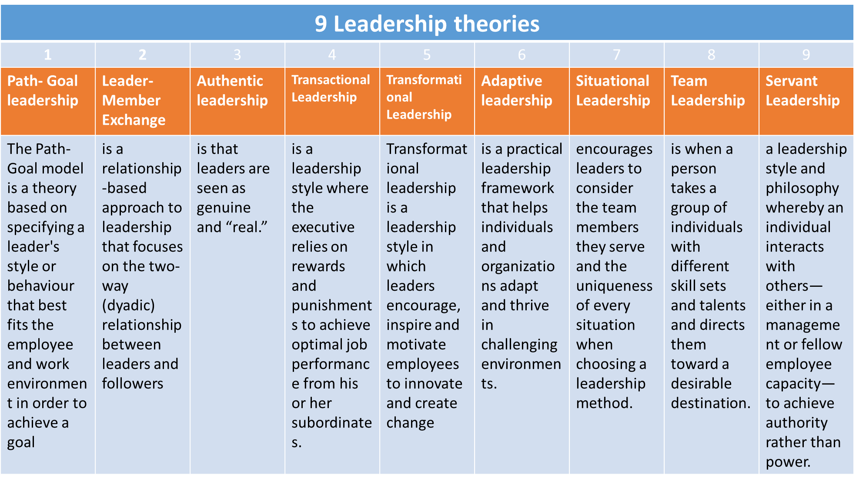

Đáp án Câu 2:
Câu 3 (30 điểm):
With your 4 community projects:
3.1 What are the key challenges of each project? What makes you proud of each project?
3.2 Which leadership skills did you and your team members use to overcome these challenges?
3.3 Group 3 did not present their project even though they had some results. What leadership lessons do you learn from this failure? What improvements would you suggest for group 3?
3.4 Bonus question - 10 points - What are the 5 rules set by our class members?
Đáp án Câu 3:
Depending on 4 projects, student could reflect themselves
Project | 3.1 Key challenges | 3.2 Leadership skills
1. VLSportsMatch  Sport promotion | Some members did not  How to build content on fan page | Planning, motivation  Event organizing
2. Say no with “wet rubbish” | 1. Product Design  2. General time  3. Many different points of view | Product Design  Survey  Data presentation  Planning, motivation
3. Meditation | Team work, leader did not perform  Give up in the last minute  Knowledge about Meditation | Communication  Team work  Be punctual
4. Here we love – Anti-depression | Team work, leader did not perform  Knowledge about depression | Idea generation and teamwork  Conflict management

3.3 Never give up, need a responsible leader, each member has to perform activities
3.4 Be on time, thinking about your project and group work before every class session, no delay, follow the deadline, good planning
Ngày biên soạn: 30.07.2022
Giảng viên biên soạn đề thi: Tạ Hùng Anh

Ngày kiểm duyệt:
Trưởng (Phó) Khoa/Bộ môn kiểm duyệt đề thi: Trưởng Khoa: Nguyễn Quỳnh Mai

- Sau khi kiểm duyệt đề thi, Trưởng (Phó) Khoa/Bộ môn gửi về Trung tâm Khảo thí qua email: bao gồm file word và file pdf (được đặt password trên 1 file nén/lần gửi) và nhắn tin password + họ tên GV gửi qua Số điện thoại Thầy Phan Nhất Linh (0918.01.03.09).
- Khuyến khích Giảng viên biên soạn và nộp đề thi, đáp án bằng File Hot Potatoes. Trung tâm Khảo thí gửi kèm File cài đặt và File hướng dẫn sử dụng để hỗ trợ thêm Quý Thầy Cô.

